Food Waste Study
Corey Gustafik
Kings College Wilkes Barre
Meals on Wheels
June 11th 2025

Table on Contents 2
Introduction 3
Objectives 4
Preparation for Food Waste Audit 5
Overview of Audit Information 6
Participants 6
Data Collection 7
Results and Data Analysis 10
Recommendation 12
Conclusion 13
References 14
Appendix 15

Introduction
In the United States, approximately 35 percent of the food supply is wasted, resulting in around 149 billion pounds according to the USDA’s Economic Research Service 2024.⁶ Food waste, landfill material being the largest category, represents not only the lost nutrients that could have supported families in need but also the wasted resources like water, energy, and labor that were used in logistics. Reducing food waste is not a single effort but it requires collaboration among federal, state, tribal, local governments, faith-based organizations, environmental agencies, communities, consumers, and food supply chains.^{1,2,3,6}
Globally, food waste is still a critical issue and needs to be addressed by all parties involved. In 2016, the USDA and the EPA launched the U.S. 2030 Food Loss and Waste Reduction Goal, aiming to cut food loss and waste in half by 2030.^{1,6} The EPA defines food waste as food sent to landfills, combustion, sewers, anaerobic digestion, composting, or land application, estimating 328 pounds per person a year in 2016.⁶ The goal would be to reduce this to 164 pounds per person by 2030. While food loss (occurring during production up to the retail levels) lacks a baseline at this point in time. Meals on Wheels has implemented innovative programs in Illinois, such as reusable trays, pre-planning to limit overproduction, and timely deliveries to maintain food quality, which indirectly reducing waste. ⁴
Purpose
To demonstrate Meals on Wheels’ commitment on mitigating food waste by conducting a food waste audit at the Bolingbrook Levy Center, following the “Student Guidelines for Food Waste Audit.”
Objectives
- Conduct a food waste audit at Joshua Arms Senior Center during the Wednesday C1 meal service.
- Collect and analyze food waste data, identify reasons for waste, develop an After-Action Report (AAR) to reduce waste across Will County sites that serve C1 meals.
- Produce an executive summary with data and images in an appendix.
- Develop a presentation for Director of Operations and Chief Executive Officer to share findings and recommendations.
Preparation of Audit
Meals on Wheels, operated by Community Nutrition Network & Senior Services Association, delivers meals to homebound seniors and individuals with disabilities and runs Cafes at sites but for this audit it was at Joshua Arms Senior Center (1315 Rowell Ave, Joliet, IL 60433). Joshua Arms C1, overseen by Michelle Gotchie, ensure daily deliveries every day and efficient café operations every weekday. This audit on the Café’s C1 meal service is to quantify and analyze food waste, aiming to enhance their reduction techniques and strategies to run the program more efficiently. The audit, scheduled for Wednesday June 11th, 2025, from 11:00am to 12:00pm, aligns with their regular café hours. On June 6th , 2025, Charmiane Conley assigned Corey Gustafik (myself) to operate and conduct the audit, with Charmaine Conley assisting in gathering supplies and working the logistics.
Audit Process
The audit follows the Guide to Conducting Student Food Waste Audits, adapted for the café’s senior congregate setting. Food waste will be collected from trays and the clients will be surveyed, with simplified questions to accommodate any potential cognitive or language barriers. All clients were fluent in English, so surveys will be offered in English only.
Equipment and Supplies
- Regular scale for weighing food waste.
- Buckets for collecting food.
- Disposable gloves and cleaning supplies.
- Clipboard, pens, and data collection forms.
- Labels sheets for each bin.
All equipment will be set up at the Joshua Arms at 10:30am on June 11th, 2025.
Staffing and Roles
- Food Collection: Corey Gustafik will collect trays and note immediate client feedback (e.g., reasons for uneaten food).
- Survey: Corey Gustafik will administer brief surveys on meal satisfaction and reasons for waste, adapted to clients’ needs.
- Weighing: Corey Gustafik will weigh and record waste data, compiling survey responses and calculating metrics.
- Cleaning and Disposal: Corey Gustafik will manage waste disposal and sanitation to maintain hygiene for equipment and the site.
Procedure
- Setup (10:30am): Arrange scale, bin, and forms: brief site manager, staff, and clients about SOP.
- Meals and Data Collection (11:00am-12:30pm): serve meals, collect food waste, administer surveys (noting reason for waste), collect food leftovers.
- Waste Management: 11:30am-12:30pm): sort and weigh food waste and leftovers, record data and maintain sanitation.
- Data compilation: Summarize waste data and analyze survey responses to identify patterns.
- Clean up: dispose of waste, sanitize equipment, and store supplies.
Considerations
- Client need: Seniors may have cognitive or physical limitations, requiring clear, respectful communications, simple questions, and food waste returns.
- Logistics: Limited time at Joshua Arms, which means Corey Gustafik had to be efficient with data collection and avoid disrupting the normal operations.
- Data accuracy: Scales will be calibrated, and food will be weighed and placed in proper bucket.
Goals
- Quantify the amount and types of food waste and left over from Café.
- Identify reasons for uneaten food.
- Provide recommendations to Meals on Wheels, such as adjusting portion sizes, modifying menus or enhance orders.
Overview of Audit Information
- Location: Joshua Arms Senior Center, 1315 Rowell Ave, Joliet, IL 60433
- Numbers of Clients Approximately 15-20 café participants
- Date: June 11th, 2025
- Meal Service: Wednesday C1 meal (lunch, 11:00am-12:00pm)
- Menu: BBQ pulled chicken, cheesy mashed potatoes, broccoli, wheat bun and chilled pears
- Staff: Corey Gustafik (Audit Manager), Michelle Gotchie (site Manager), Charmaine Conely (Corey’s Preceptor)
Data Collection:
Data will be collected onsite by assigned participants. The following tables summarize meal service, equipment weights, food weights and percentages and survey results:
Table1:
meal Service- Menu Description (11:00am-12:00pm)
Food Item | Presentation Format
Pasta | Pan
BBQ pulled chicken | Pan
Cheesy mashed potatos | Pan
broccoli | Pan
Wheat bun | Pan served in container
Chilled pears | Pan, packaged in container

Table 2:
weight of equipment
Weight of pans and buckets
1 Pan=0.28 lbs.
Bucket 1= 0.88lbs
Bucket 2=0.72 lbs.

Table 3:
Weight and units of food received.
Meal Service | Food Items | Presentation Format | Total Weight or Units
Lunch  11:00am-12:00pm | Pasta | Pan | 7.22lbs
Lunch  11:00am-12:00pm | Marinara sauce | Pan | 13.1lbs
Lunch  11:00am-12:00pm | Alfredo Sauce | Pan | 11.68lbs
 | Chicken | Pan | 10.14lbs
 | Italian Salad | Pan | 5.42lbs (x2)
 | Italian Dressing | Container within Pan | 10.2lbs
 | Fresh Fruit | Pan | 20.24lbs
 | Whole grain rolls | Individual | 12 units

Table 4:
Client Survey
Type of Food  (one item per line) | Loss Reason  (ex. Didn’t like, not enough detail)
1.pasta with alfredo sauce | Didn’t like the taste
2.marinara sauce | Too much sauce
3.italian salad | Doesn’t like cucumbers
4.salad dressing | Didn’t like the taste
5.salad dressing | Didn’t like the taste
6.marinara sauce | Too much sauce
7.garlic bread | Didn’t like the taste
8.Italian salad | Didn’t like the taste and too much food
9.garlic bread | Didn’t like that taste
10.Italian dressing | Too much dressing
11.garlic bread and pasta | Too much
12.Italian salad | Too plain and bland
13.Italian dressing | Too much dressing
14. Italian dressing | Too much dressing
15. Italian dressing | Too much dressing
16. Italian dressing | Too much dressing
17.italian dressing and salad | Too much dressing
18. garlic bread | Didn’t like the taste

Table 5:
food items for recycling or reuse
Item | End Weight |  | Reasoning | Food wasted Weight | Food Waste %
Bucket #1 | 13.42lbs | Leftovers |  | Marinara Sauce-5.36lbs  Alfredo Sauce -5.65lbs  Italian Dressing-1.85  Whole grain rolls-0.12 | Marinara Sauce- 40%  Alfredo Sauce-42%  Italian Dressing -13.8%  Whole grain rolls-0.009%
Bucket #2 | 4.28lbs | Food waste |  | Marinara Sauce 0.12  Alfredo Sauce-0.13  Italian Dressing-3.53  Garlic Bread-0.12  Italian Salad-0.14  Fruit Salad-0.24 | Marinara Sauce -0.03%  Alfredo Sauce-0.03%  Italian Dressing-82.5%  Garlic Bread-0.03%  Italian Salad-0.03%  Fruit Salad-0.56%

Note: individual packaged items (e.g., milk cartons, water) will not be counted because the site itself supplied these resources.

Table 6:
Initial food weight, leftover weight/ percentage, and food waste weight/ percentage
Meal Service | Food Items | Total Weight or Units w/o pan weight | leftover Weight (13.42lbs) |  | left-over % | Food Waste Weight (4.28lbs) | Food Waste %
lunch 11:am-12:15pm | Pasta | 7.22lbs in Pan | 0.00lbs | 0 |  | 0.00lbs | 0%
 | marinara Sauce | 13.1lbs in Pan | 5.36lbs | 0.4 |  | 0.12lbs | 0.03%
 | Alfredo Sauce | 11.68lbs in Pan | 5.65lbs | 0.42 |  | 0.13lbs | 0.03%
 | Chicken | 10.14lbs in Pan | 0.00lbs | 0 |  | 0.00lbs | 0%
 | Italian Salad | 5.42lbs (x2) in Pan | 0.00lbs | 0 |  | 0.14lbs | 0.03%
 | Italian Dressing | 10.20lbs | 1.85lbs | 0.138 |  | 3.52lbs | 82.50%
 | Fresh Fruit | 20.24lbs | 0.00lbs | 0 |  | 0.24lbs | 0.56%
 | Whole Grain Rolls | 12 units | .12lbs | 0.00009 |  | 0.00lbs | 0%
 | Garlic Bread | 5.14lbs | 0.00lbs | 0 |  | 0.12lbs | 0.03%

Table 7:
Food waste and Leftover percentage by food item
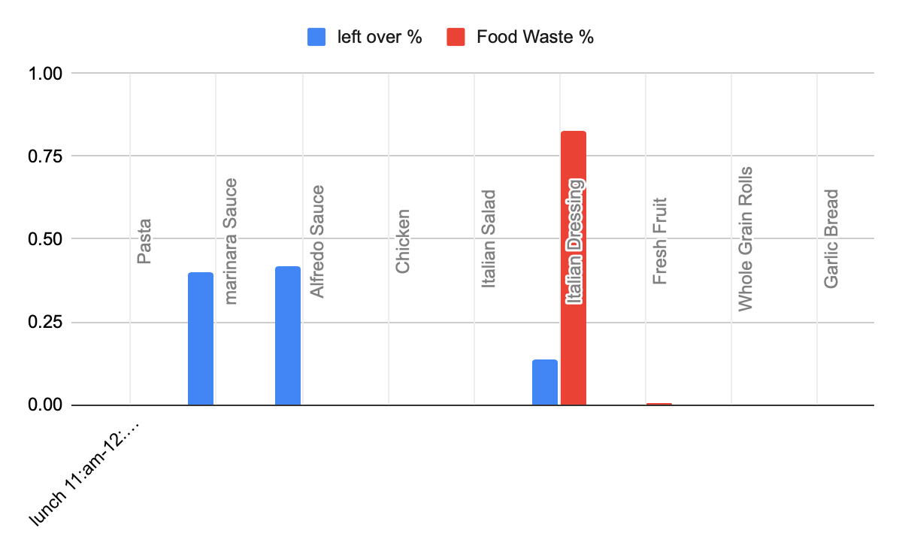
Table 8:
Type of food loss by category

Table 9:
Percentage of food loss by category

Results and Data Analysis

Initial food weight will be treated as 100%, with wasted food weighed and calculated as a percentage. Survey responses will be analyzed to identify patterns and data will be represented in tables and charts to highlight total waste and key contributors.
Recommendations
- Adjust portion size: reduce portions for high-waste items (e.g., Italian dressing and sauces) based on client consumptions patterns and leftovers
- Modify Menu: replace unpopular items (e.g., Italian dressing, garlic bread, and whole grain rolls) with alternatives based on client feedback or adjust recipes to improve taste.
- Implement Pre-ordering: Introduce a more efficient RSVP or pre order system to better estimate the needs and coordinate with food vendor to adjust food sizes.
- Enhance Staff training: provide workshops on waste reduction techniques, including portion control and client engagement.
- Adopt Sustainable packaging: Use reusable or recycling container for sauces and individual items to minimize waste.
Conclusion
The food waste audit at Joliet’s Joshua Arms Senior Center with Meals on Wheels commitment to the U.S. 2030 Food Loss and Waste reduction Goal. By following the Student Guidelines for Food Waste Audits, this study provides actionable insights to reduce waste, optimize resources and enhance service sustainability. The site did not have a large amount of food waste on their end, but the food vendor portion sizes contributed to most of the food waste because of the inaccurate sizes of sauces related to food.

References

1.EPA. (2025). National Strategy for Reducing Food Loss and Waste and Recycling Organics. https://www.epa.gov/sustainable-management-food/national-strategy-reducing-food-loss- and-waste-and-recycling-organics
2.FDA. (2025). Food Loss and Waste. https://www.fda.gov/food/consumers/food-loss-and-waste
3.Greenly. (2024). Global Food Waste in 2024. https://www.greenly.earth/en- us/blog/industries/global-food-waste-in-2022
4.Meals on Wheels America. (2024). Nutrition Programs and Food Security. https://www.mealsonwheelsamerica.org/our-programs/nutrition
5.ReFED. (2021). Roadmap to 2030: Reducing U.S. Food Waste by 50%. https://www.refed.org/insights/roadmap-to-2030
6.USDA. (2024). Food Loss and Waste FAQs. https://www.usda.gov/foodlossandwaste/faqs
World Resources Institute. (2016). Food Loss and Waste Accounting and Reporting Standard. https://www.wri.org/research/food-loss-and-waste-accounting-and-reporting- standard

Appendix
Table1: meal Service- Menu Description (11:00am-12:00pm)
Food Item | Presentation Format
Pasta | Pan
Marinara sauce | Pan
Alfredo sauce | Pan
Chicken | Pan
Italian salad | Pan served in container
Italian dressing | Pan, packaged in container
Fresh fruit | Pan served in container
Garlic Bread | Pan
Whole grain rolls | 12 units

Table 2: weight of equipment
Weight of pans and buckets
1 Pan=0.28 lbs.
Bucket 1= 0.88lbs
Bucket 2=0.72 lbs.

Table 3: Weight and units of food received.
Meal Service | Food Items | Presentation Format | Total Weight or Units
Lunch  11:00am-12:00pm | Pasta | Pan | 7.22lbs
Lunch  11:00am-12:00pm | Marinara sauce | Pan | 13.1lbs
Lunch  11:00am-12:00pm | Alfredo Sauce | Pan | 11.68lbs
 | Chicken | Pan | 10.14lbs
 | Italian Salad | Pan | 5.42lbs (x2)
 | Italian Dressing | Container within Pan | 10.2lbs
 | Fresh Fruit | Pan | 20.24lbs
 | Whole grain rolls | Individual | 12 units

Table 4: Client Survey
Type of Food  (one item per line) | Loss Reason  (ex. Didn’t like, not enough detail)
1.pasta with alfredo sauce | Didn’t like the taste
2.marinara sauce | Too much sauce
3.italian salad | Doesn’t like cucumbers
4.salad dressing | Didn’t like the taste
5.salad dressing | Didn’t like the taste
6.marinara sauce | Too much sauce
7.garlic bread | Didn’t like the taste
8.Italian salad | Didn’t like it and too much
9.garlic bread | Didn’t like it
10.Italian dressing | Too much
11.garlic bread and pasta | Too much
12.Italian salad | Too plain and bland
13.Italian dressing | Too much
14. Italian dressing | Too much
15. Italian dressing | Too much
16. Italian dressing | Too much
17.italian dressing and salad | Too much
18. garlic bread | Didn’t like the taste

Table 5: food items for recycling or reuse
Item | End Weight |  | Reasoning | Food wasted Weight | Food Waste %
Bucket #1 | 13.42lbs | Leftovers |  | Marinara Sauce-5.36lbs  Alfredo Sauce -5.65lbs  Italian Dressing-1.85  Whole Grain rolls-.12 | Marinara Sauce- 40%  Alfredo Sauce-42%  Italian Dressing -13.8%  Whole grain rolls-0.009%
Bucket #2 | 4.28lbs | Food waste |  | Marinara Sauce0.12  Alfredo Sauce-0.13  Italian Dressing-3.53  Garlic Bread-0.12  Italian Salad-0.14  Fruit Salad-0.24 | Marinara Sauce -0.03%  Alfredo Sauce-0.03%  Italian Dressing-82.5%  Garlic Bread-0.03%  Italian Salad-0.03%  Fruit Salad-0.56%

Note: individual packaged items (e.g., milk cartons, water) will not be counted because the site itself supplied these resources.
Table 6: Initial food weight, leftover weight/ percentage, and food waste weight/ percentage
Meal Service | Food Items | Total Weight or Units w/o pan weight | leftover Weight (13.42lbs) |  | left-over % | Food Waste Weight (4.28lbs) | Food Waste %
lunch 11:am-12:15pm | Pasta | 7.22lbs in Pan | 0.00lbs | 0 |  | 0.00lbs | 0%
 | marinara Sauce | 13.1lbs in Pan | 5.36lbs | 0.4 |  | 0.12lbs | 0.03%
 | Alfredo Sauce | 11.68lbs in Pan | 5.65lbs | 0.42 |  | 0.13lbs | 0.03%
 | Chicken | 10.14lbs in Pan | 0.00lbs | 0 |  | 0.00lbs | 0%
 | Italian Salad | 5.42lbs (x2) in Pan | 0.00lbs | 0 |  | 0.14lbs | 0.03%
 | Italian Dressing | 10.20lbs | 1.85lbs | 0.138 |  | 3.52lbs | 82.50%
 | Fresh Fruit | 20.24lbs | 0.00lbs | 0 |  | 0.24lbs | 0.56%
 | Whole Grain Rolls | 12 units | .12lbs | 0.00009 |  | 0.00lbs | 0%
 | Garlic Bread | 5.14lbs | 0.00lbs | 0 |  | 0.12lbs | 0.03%

Table 7: Food waste and Leftover percentage by food item
Table 8: Type of food loss by category

Table 9: Percentage of food loss by category

Collection and Pictures from site
